# Consultation on Aberaeron Library

We want to hear your views on our proposals for Aberaeron library.

The consultation will start on the **23rd of May 2024**

The closing date will be **9th of July 2024**

Thank you for taking the time to provide us with feedback.

If you need this consultation in any other format (for example large print), please contact us on 01545 570881 or via clic@ceredigion.gov.uk.

# Background

The Council is currently undertaking a review into the use of its buildings in an attempt to provide more central and efficient services to our citizens, as well as to those who visit Ceredigion. One area we are currently exploring is the use of County Hall in Aberaeron, which offers a Library Service and a Face-to-Face Customer Service, offering advice and assistance to the public.

Following the implementation of the hybrid working scheme that is available to Council staff, the County Hall building is now solely occupied by the two services referred to above. Due to the rise in costs to occupy and maintain buildings, the Council must consider more affordable ways to continue the delivery of these essential services. The existing Aberaeron library is based in a section of an old and inefficient building. All other Council Services have been relocated to other buildings and the cost to run and maintain the building cannot be met by the library service alone.

In addition, the Council is facing significant budget challenges. As part of the budget setting arrangements that were agreed by Council on the 29th of February 2024, it was agreed that a library provision would be retained in each of the 4 current towns and that the provisions would be co-located with other Council Services where-ever possible.

The Council is therefore considering whether to remain with the status quo, resulting in additional increasing running costs, or our favoured position which would be to re-locate the library and the Face-to-Face Customer Service provision to the ground floor of the Council Offices at Penmorfa, which is located on the southern side of the town.

Aberaeron library delivers services to both the town of Aberaeron and the surrounding rural areas. In contrast to the facilities available at County Hall, Penmorfa will offer onsite parking (including disabled parking spaces near the door), as well as its close proximity to a bus stop, safe walking routes into the town, Aberaeron Primary School and Min y Mor Residential Care Home. The community mobile library van will also be able to operate from the new site.

If this proposal was to be agreed, we would be able to offer an improved library and customer service along with access to the new [Centre for Independent Living](https://uccc.ceredigion.gov.uk/resident/wellbeing-and-care/support-for-adults/penmorfa-centre-for-independent-living/). (See image 1 & 2) The Penmorfa Centre for Independent Living promotes independence and community support and is set to transform the way individuals find solutions and access information to help themselves. The centre provides the opportunity to see a range of solutions related to Care, Technology, Mobility and Independent Livings. The centre is committed to suggesting practical solutions to all age groups. This would offer individuals a host of services in one place and promote our aim to provide a collaborative service to the public.

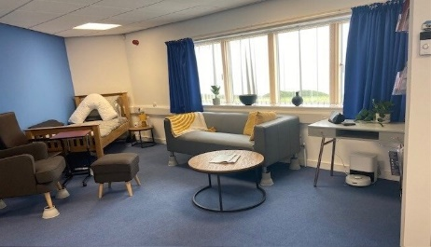 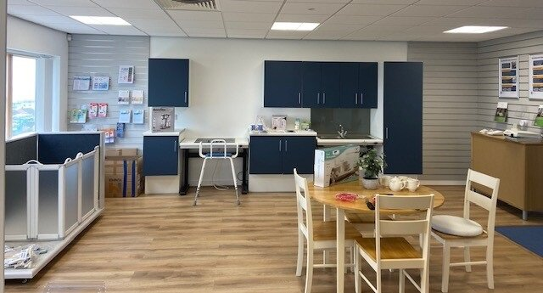

Image 1 Image 2

The proposal would also address sustainability considerations and our Net Zero ambitions through the reduction of the carbon footprint of the library service, taking advantage of existing renewable energy and efficiencies through co-locating services.

Re-locating to Penmorfa would also provide a larger space for a children’s book collection along with additional space to support workers and learners including a dedicated work room. The proposal would modernise library provision with the inclusion of a Maker Space. This is a dedicated area where library users can get creative and use shared resources such as an advanced sewing machine, 3D printer, Internet of Things sensors and other creative opportunities, a space which could also be utilised for training and group workshops. In total there is the potential opportunity to secure capital investment in a new improved and enlarged facility of at least £250,000.

This consultation is focused on obtaining the views and comments of individuals in respect of the future provision of Library and Face-to-Face Customer Services in Aberaeron.

In order to provide further information regarding the current and proposed provision please see the images below

### Current Layout in County Hall

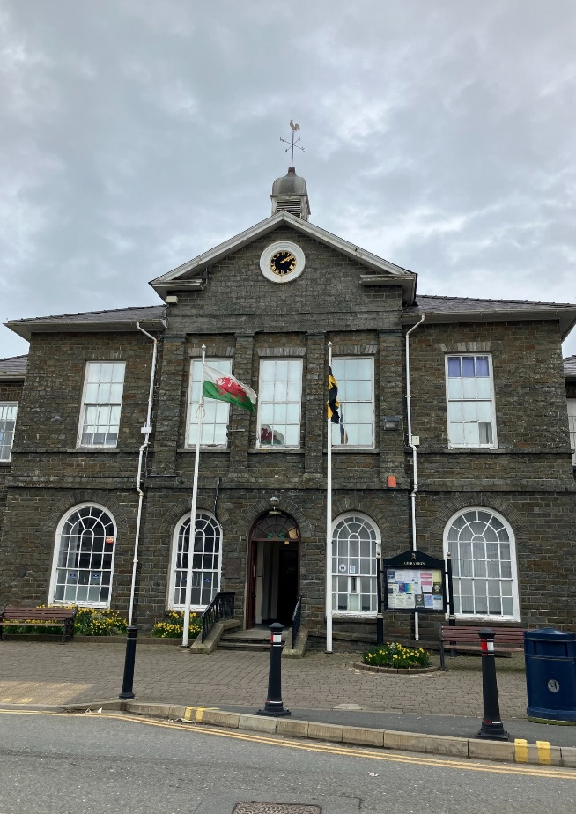

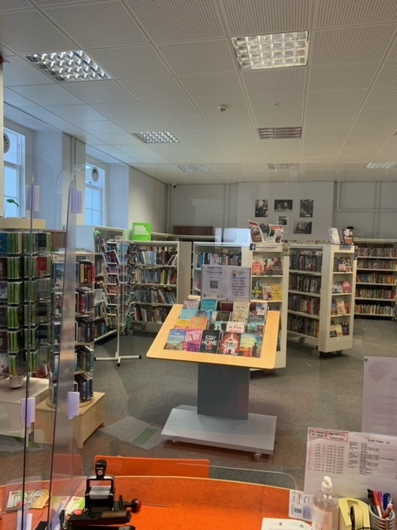

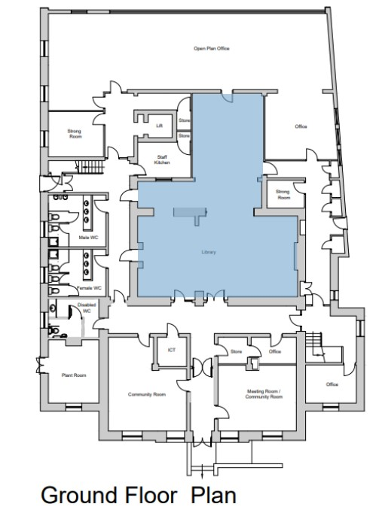

##### Ground Floor Plan

##### Proposed Layout in Penmorfa

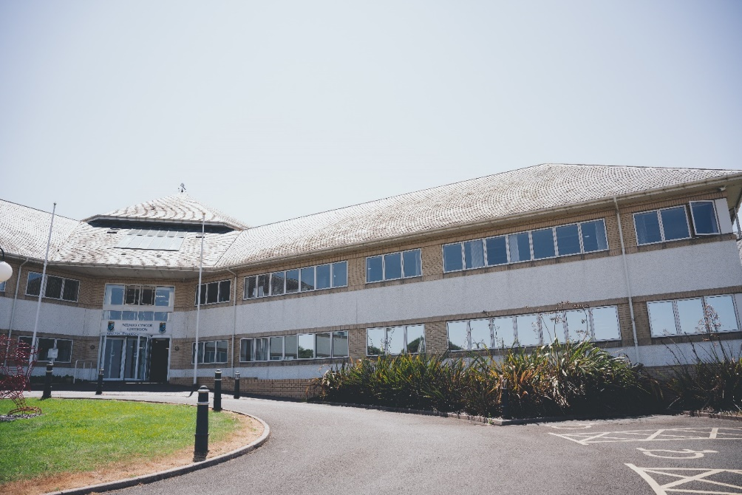

Reception area (to be refurbished with new glass wall entrance to the library)

#### Possible plans

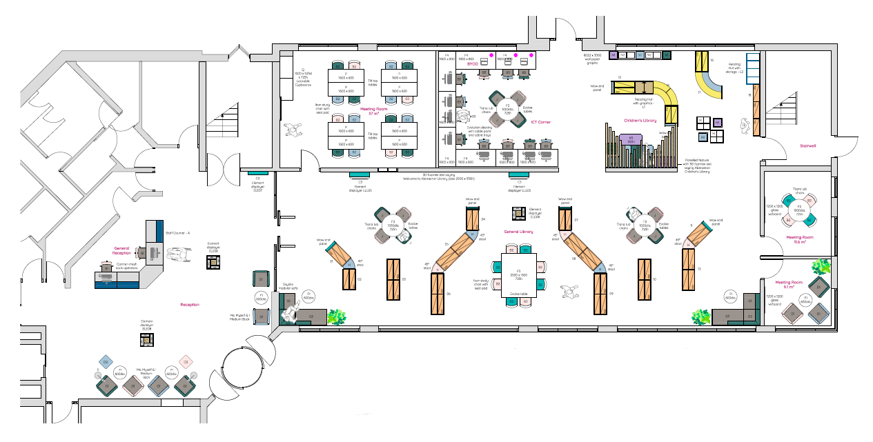

## Questions

1. Are you?
   * An existing library user.
   * Ceredigion Resident.
   * Someone who represents Ceredigion County Council? (A Staff member / Councillor).
   * Someone representing a Ceredigion business or community organisation.
   * Other – please specify.
2. Do you agree that co-locating the library with other service areas, as suggested in the proposal, would lead to efficiencies?

* Strongly agree
* Agree
* Neither agree nor disagree
* Disagree
* Strongly disagree

1. Do you agree that co-locating with other services and increasing the space available, as detailed in the proposal, will lead to better customer support?

* Strongly agree
* Agree
* Neither agree nor disagree
* Disagree
* Strongly disagree

1. Please use the space below to provide further comments you would like to make on the proposal.
2. Do you think the proposal would encourage additional Library users?
   * Yes
   * No
   * Neutral
3. If the proposal is to go ahead, are there any additional services or resources you would like to see offered in the library?
4. Do you think that the proposal to re-locate the library will assist the Council in achieving its Net Zero Carbon Ambitions?

* Yes
* No
* Neutral

1. Do you support the proposal to re-locate the Library and Face to Face Customer Service provision to Penmorfa?

* Yes
* No
* Neutral

**Equality Monitoring Questions**

Answering the following questions will help us ensure we have collected the views of a variety of people and given everyone from all backgrounds a chance to take part. You do not have to answer them. The information will only be used for statistical analysis.

1. How old are you?

* 0-15
* 16-24
* 25-44
* 45-64
* 65+
* Prefer not to say

1. What is your gender?
   * Male
   * Female
   * Non-binary
   * I prefer to use another term
   * Prefer not to say
2. Is your Gender the same now as when assigned at birth?
   * Yes
   * No
   * Prefer not to say
3. Which of the following best describes how you think of yourself?
   * Heterosexual / Straight
   * Gay, lesbian or queer
   * Bisexual
   * Another sexual orientation
   * Prefer not to say
4. How would you describe your national identity?
   * British
   * Cornish
   * English
   * Northern Irish
   * Scottish
   * Welsh
   * Other national identity
   * Prefer not to say
5. How would you describe your ethnic group?
   * Asian, Asian British or Asian Welsh
   * Black, Black British, Black Welsh
   * Caribbean or African
   * Mixed or Multiple ethnic
   * White
   * Other ethnic group
   * Prefer not to say
6. What is your religion or belief?
   * Christian
   * Buddhist
   * Hindu
   * Jewish
   * Muslim
   * Sikh
   * No religion
   * Other religion or belief
   * Prefer not to say
7. Have you previously served in the UK Armed Forces (current members should tick ‘No’)
   * Yes, in regular armed forces
   * Yes, in reserve armed forces
   * No
   * Prefer not to say
8. Do you have any long term physical or mental health condition or illness that reduces your ability to carry out day-to-day activities?
   * Yes, my day-to-day activities are limited a lot
   * Yes, my day-to-day activities are limited a little
   * No
   * Prefer not to say
9. What is your preferred language?
   * Welsh
   * English
   * Prefer not to say
10. Can you understand, speak, read, or write Welsh?
    * Understand spoken Welsh
    * Speak Welsh
    * Read Welsh
    * Write Welsh
    * None of the above
    * Prefer not to say

# **How to respond to this consultation**

**Ceredigion County Council Website:** [Consultation on Aberaeron Library - Ceredigion County Council](https://www.ceredigion.gov.uk/your-council/consultations/consultation-on-aberaeron-library/)

**Paper copies of the consultation can be accessed at our customer contact locations:**

* Aberystwyth Library
* Lampeter Library
* Aberaeron Library
* Cardigan Library

If you need this consultation in any other format (for example large print or Easy Read), please contact us on 01545 570881 or via clic@ceredigion.gov.uk.

**Thank you** for taking the time to complete this consultation. We value the information you have provided.

**What happens next?**

A **report**, communicating the findings from the consultation, will be produced, and presented to a cabinet meeting for a final decision. The report will be made available on the Council’s website on the Engagement and Consultation page.